# FusionDocs Operation

2/9/2018

This program is used to process Boeing documentation updates. Once the program is installed on your computer, you may process documentation updates via the following steps:

* Go to the Exostar web site and download any new updates. These files are in CSV format and you should place them in a source directory on your hard drive. This document assumes that directory is c:\FusionDocs, but it can be anything you desire. It is best to include the date in the CSV file name so that older files can be retained.
* Start FusionDocs by double-clicking its link on your desktop. It looks like this:

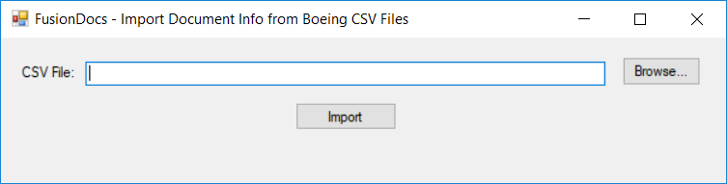

* Click on the **Browse…** button and navigate to the source directory in which you store CSVs. Select the desired CSV and click **Open**.

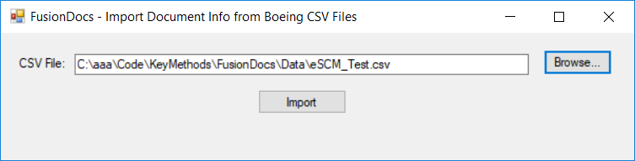

* Now click the **Import** button. It may take up to a minute for the file to be processed. When FusionDocs is done, it will display the number of documents in the CSV file:

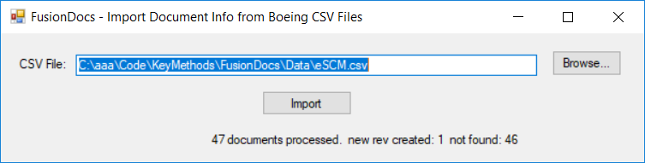

An Excel spreadsheet is also displayed. This spreadsheet is created in the same directory as the source CSV file with the same name except with an XLSX extension. It contains two tabs.

### Excel Docs Tab

This spreadsheet lists all the relevant document revs appearing in the CSV file. It contains all the original columns plus a DocStat column at the beginning and a DocRef column at the end. The raw data for this tab exists in the _FusionDocs table of the database. The DocStat column has one of three values:

|  |  |
| --- | --- |
| **Value** | **Description** |
| new rev created | This document already existed with a different revision. The new revision has been created, copying most of the other parameters from the old revision. |
| rev exists | This document already exists with this revision. No further action is required. |
| not found | There are no documents with this number and therefore no description is available. |

Note that documents showing rev ‘-‘ are now modified to show the rev as ‘NEW’.

Documents in the Excel file will be matched with existing documents in Fusion according to the following logic:

|  |  |  |
| --- | --- | --- |
| **CSV Acronym (Type)** | **Sheet ID** | **Append to Boeing Doc #** |
| PL or EPL |  | PL |
| LWG |  | LWG |
| PSDL |  | DL |
| SSP |  | SSP |
| SPECO |  | SPECO |
| <anything> | XXX | .SHTXXX up to 30 character max  XXX 6 characters max |
| others |  | <match exact Doc # only> |

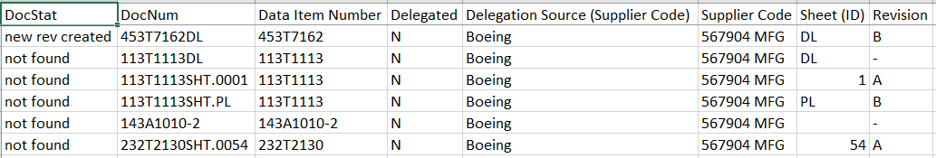

### Excel MOs Tab

This tab shows any open MOs that include an earlier rev of documents from the CSV in their document list. The old and new revisions are provided:

